# CS 255 System Design Document Template

## UML Diagrams

### UML Use Case Diagram

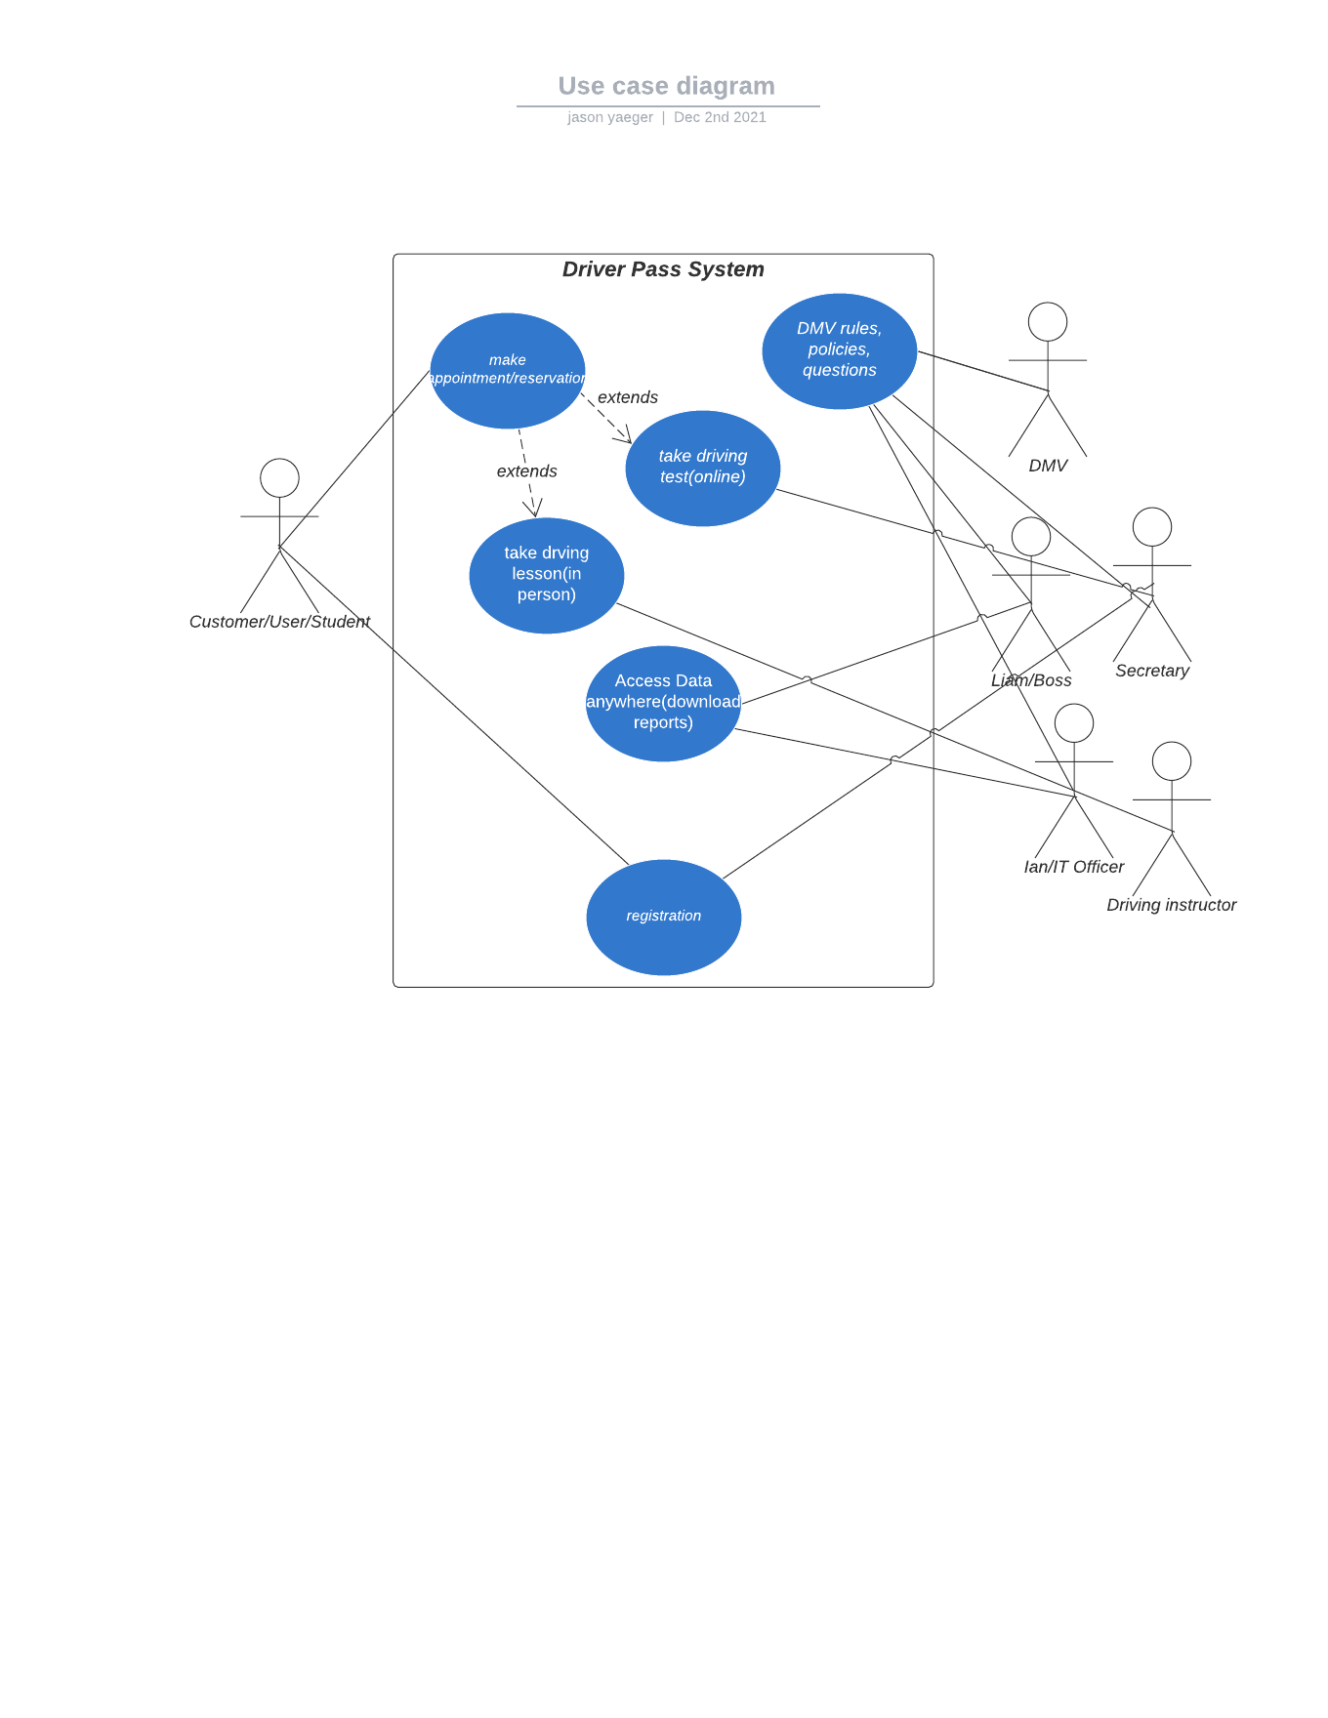

### UML Activity Diagrams

### 

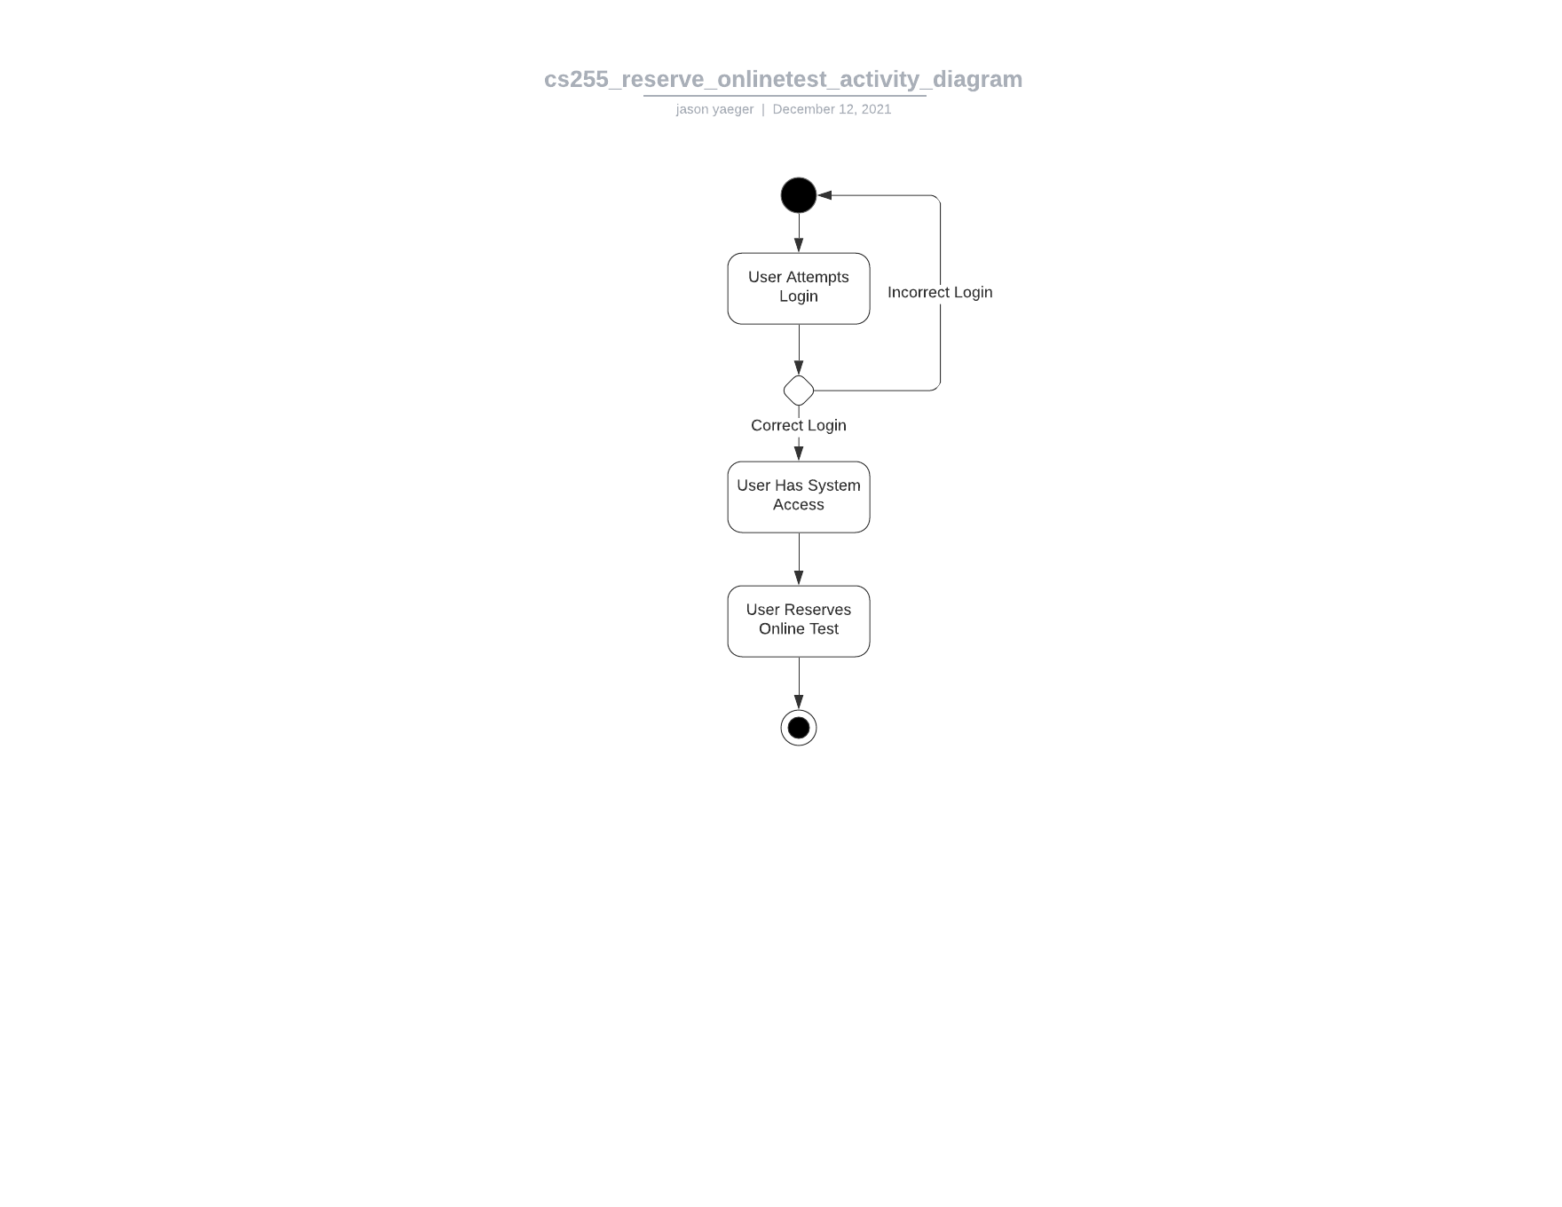

### UML Sequence Diagram

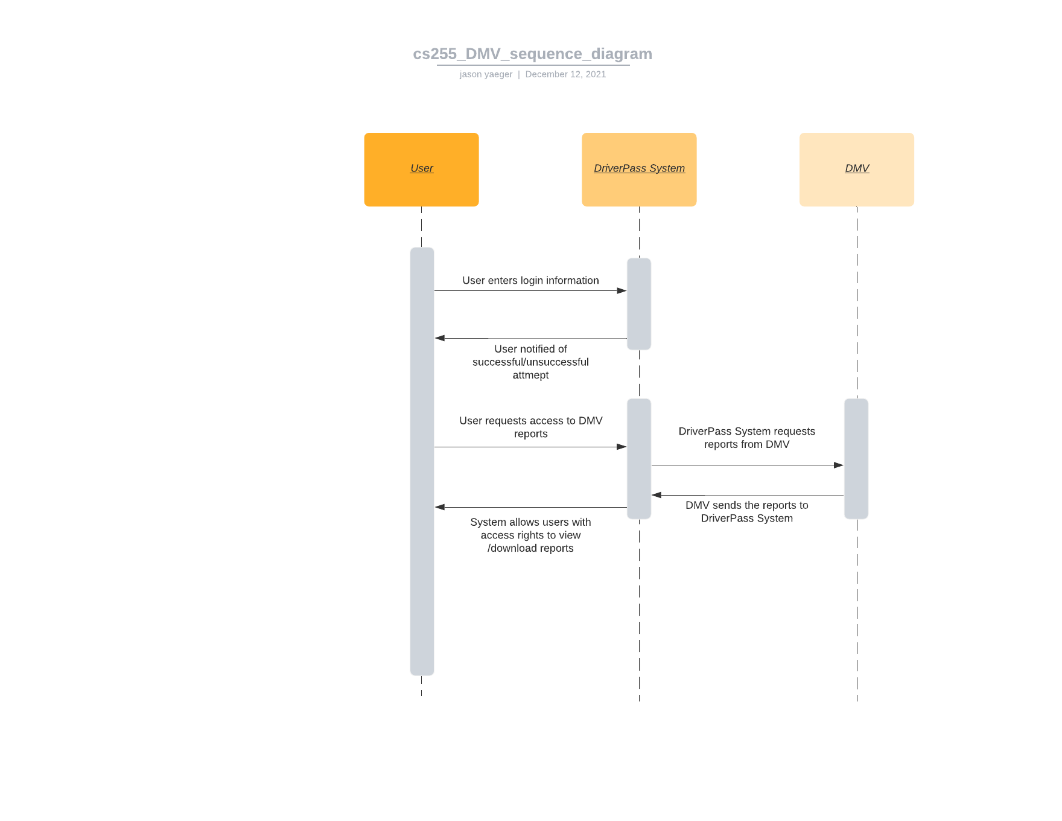

### UML Class Diagram

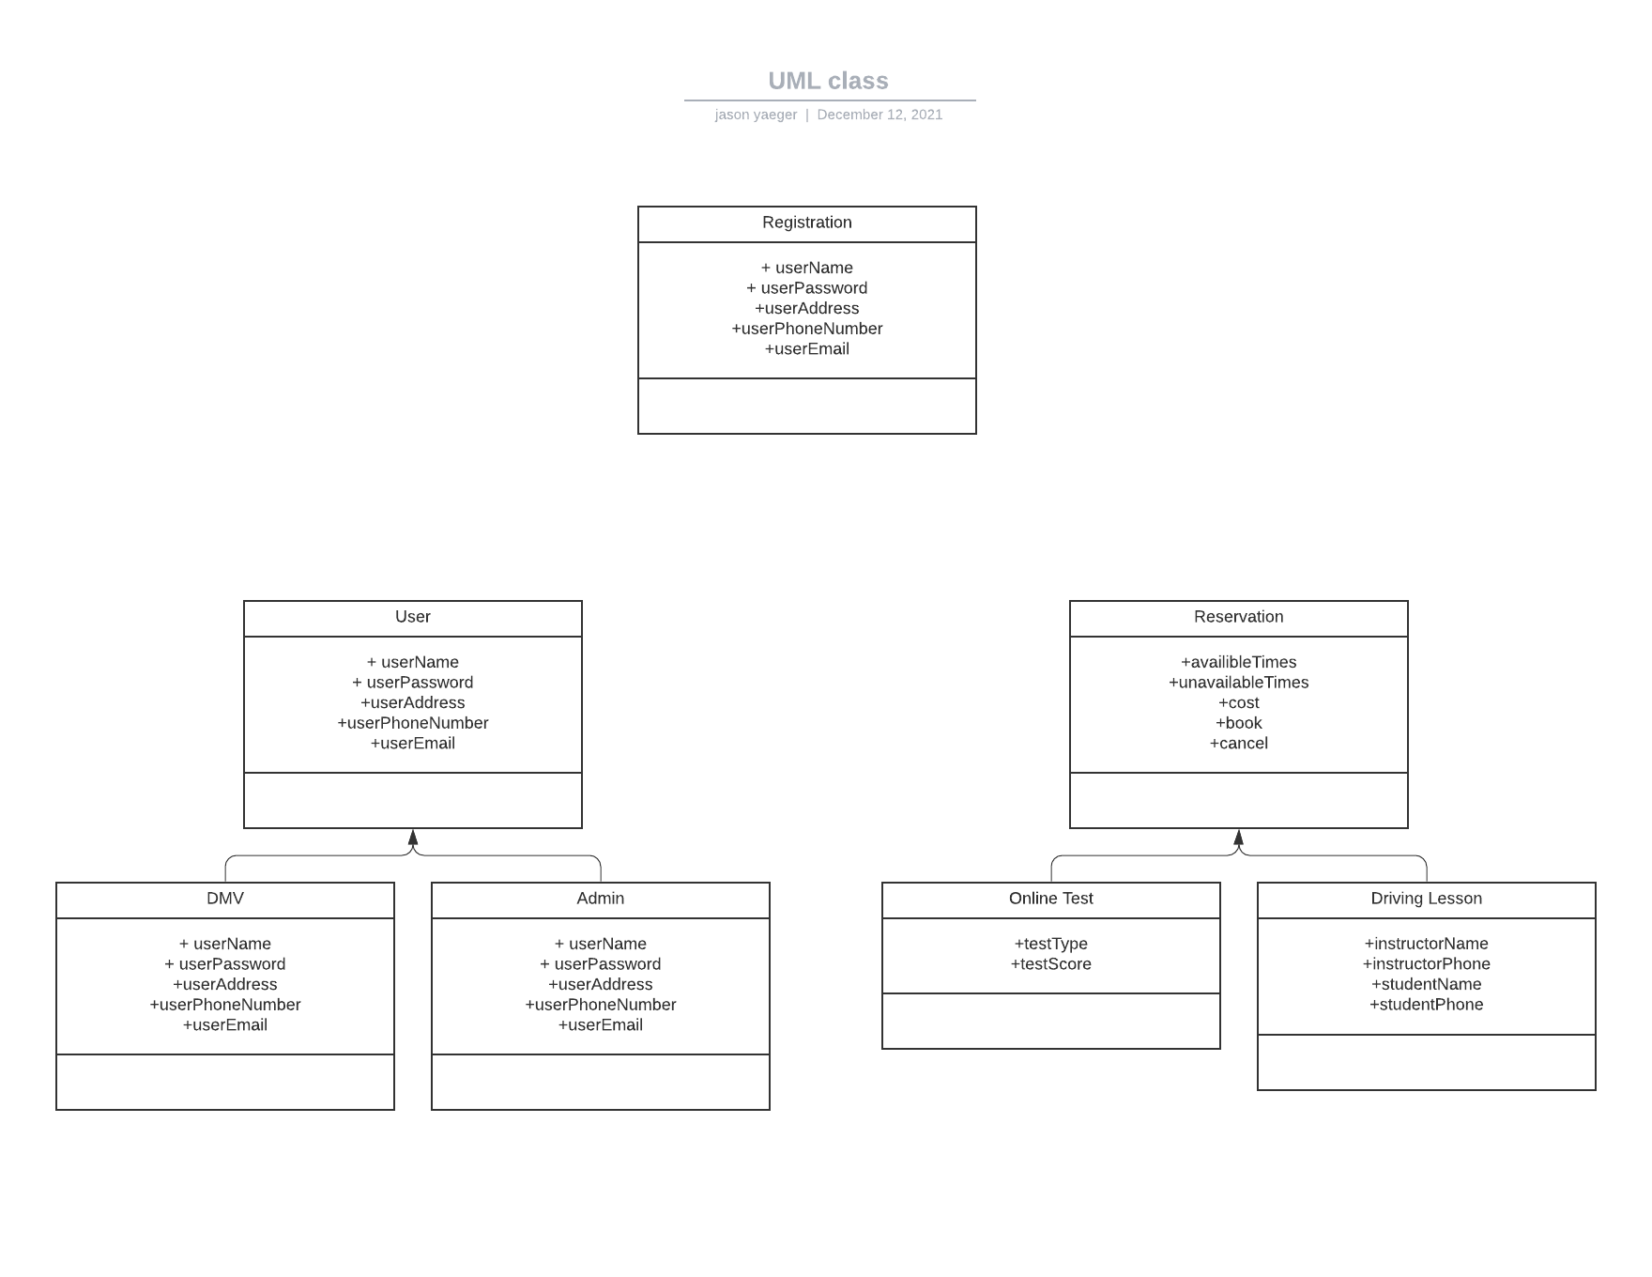

## Technical Requirements

The DriverPass system will have limited hardware requirements as it will be hosted in the cloud via Amazon Web Services or a similar competitor. Hardware usage will then be placed in the hands of users, how they choose to access the system whether it be PC, mobile, etc. Software requirements involve having enough storage space and data via the cloud provider. It will be important for the system to be scalable as more and more users are onboarded. Tools and infrastructure are again handled by the cloud provider. If this system was done in house it would be a much more interesting discussion. Something important to note is that there is great priority on the system being accessible, and the cloud will provide near 100% uptime. Data/reports will also be downloadable. The system is not inherently demanding and will not require any unique solutions.